1. We saw form-based authentication which is suitable for web app but we want to secure our REST endpoints.
2. Let’s provide Basic-Authentication.
3. 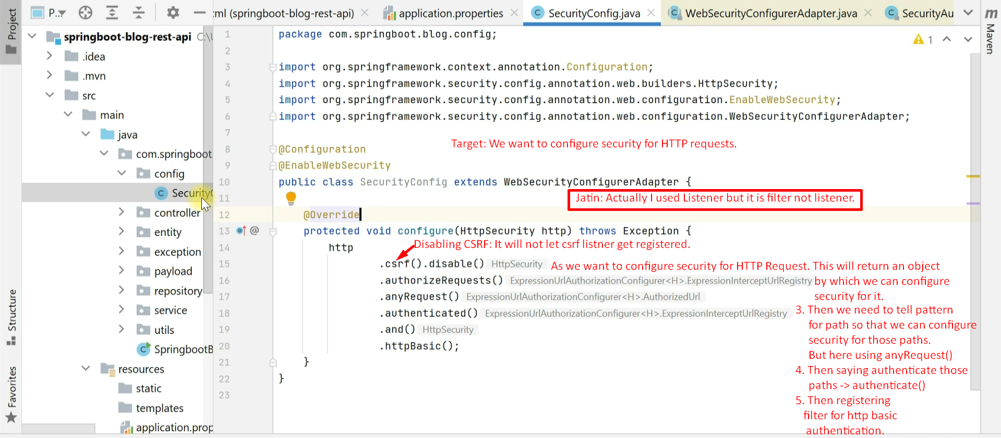
4. 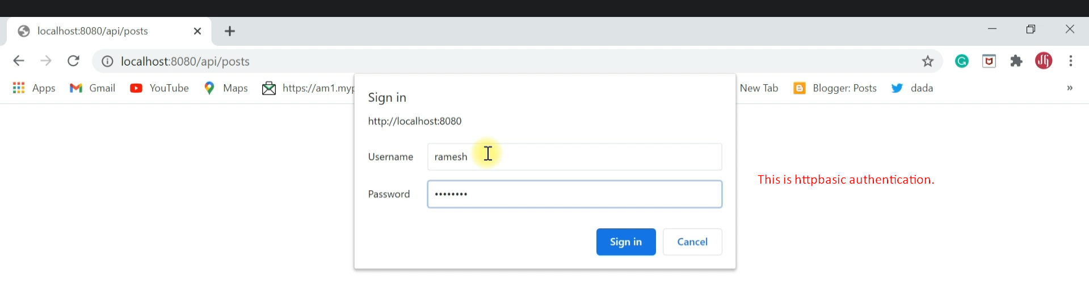
5. 